PRAYAG PUBLIC SCHOOL
CLASS - 12th
PHYSICS ASSIGNMENT (HOLIDAY HOMEWORK)
Date: (1/ 6/2020 to 10/6/2020)
Note : Attempt all the questions compulsory .
Each assignment carrying marks.
Do it in a separate copy with neat and clean work.
Subjective:
Level – O
- How does the force between two point charges change if the dielectric constant of the medium in which they are kept increases.
- Two point charges of unknown magnitude and sign are placed at a distance d apart the electric field intensity is zero at a point not between the charges but on the line joining them. Write two essential conditions for this to happen.
- Show that no electric field exist inside of hollow charged conductor
- What is the electrostatic shielding
- What are the properties of electrostatic line of force
- Sketch the electric lines of force for two positive charges Q1 and Q2 where (Q1 > Q2) separated by a distance d
- Define the term electric flux state its unit
A sphere S1 of radius R1 encloses a charge q if there is another concentric sphere S2 of radius R2 where R2 >R1 and there be no additional charges between S1 and S2. find the ratio of electric flux through S1 and S2.
- State the Gauss's theorem in electrostatics. Apply this theorem to calculate the electric field due to an infinite plane sheet of charge.
- Define electric potential. Deduce an expression for the electric potential at a point distant ‘r’ from point charge q.
- How much work is done in moving a 500 micro coulomb charge between two points on an equipotential surface.
- Define intensity of electric field at a point. At what point is the electric dipole field intensity parallel to the line joining the charges.
- Name the physical quantity whose SI unit is 1)- Coulomb / volt. 2)-Newton /Coulomb . 3)- joule / Coulomb
- What is the ratio of electric field intensity at any two point between the plates of a parallel plate capacitor
- Prove that the energy stored in a parallel plate capacitor is is ½ cv².
- What is dielectric. A dielectric slab of thickness t is kept between the plates of a parallel plate capacitor separated by a distance d. Derive the expression for the capacity of the Capacitor for t<<d.
- Define dielectric constant of a medium in terms of force between electric charges.
- Draw a diagram to show lines of force in a plane containing two equal point charges of opposite sign separated by a small distance. Giving reason indicate on the diagram a point where a small positive charge experiences a force parallel to the line joining the two charges.
- Derive an expression for electric field intensity at any point along the axial line of an electric dipole.
- Derive an expression for the total work done in rotating an electric dipole through an angle theta in a uniform electric field.
- Define intensity of electric field at a point. At what point is the electric dipole field intensity e parallel to the line joining the charges?
- Using Gauss law show that no electric field intensity exist inside a hollow charged conductor.
- What is an equipotential surface show that the electric field is always directed perpendicular to an equipotential surface?
- Force of attraction between two point charges placed at a distance d apart in a medium is F. What should be the distance apart in the same medium so that the force of attraction between them becomes 9F.
- A Proton is moved in a uniform electric field of 1.7 × 10 ⁻⁴ N/C between two points A and B separated by a distance of 0.1 m.
1- what is the potential difference between the points?
2-how much work is 1 in the above process.
- Derive the expression for the capacitance of a parallel plate capacitor having two identical plates each of area A and separated by a distance d. When the space between the plates is filled by a dielectric medium.
PRAYAG PUBLIC SCHOOL
CLASS - 12th
PHYSICS ASSIGNMENT (HOLIDAY HOMEWORK)
Date: (11/ 6/2020 to 20/6/2020)
Note : Attempt all the questions compulsory .
Each assignment carrying marks.
Do it in a separate copy with neat and clean work.
Subjective:
Level – 1

- The charges Q1 and Q2 are placed at the corners of a square as shown in the figure. Find Q2 such that the resultant force on Q1 is zero.
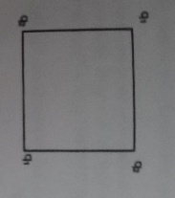

- Five point charges each of magnitude + Q are kept at the corner A,B,C,D and E of a regular hexagon of side a . find the electric field at the centre O of the hexagon.
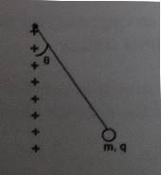
- A small sphere of mass m carries a charge q. It hangs from a light inextensible thread of length L making an angle theta with an infinite line of charge as shown in the figure. Find the linear charge density of the line charge.
- A circular wire of radius R carries a total charge q distributed uniformly over it circumference . Small length of wire subtending angle α at the centre is cut off . Find a magnitude of electric field at the centre due to the remaining portion.
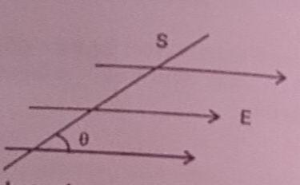
- A plane surface of area S is inclined at an angle theta with a uniform electric field as shown in figure. Find the flux of Electric field over S.

- Twenty seven identical Mercury drops are charge simultaneously to the same potential of 10 volt . What will be the potential, if all the charged drops are made to combine to form one large drop. Assume all drops to be spherical.
- The electric field at a point due to point charge 30N/C, and the electric potential at that point is 15J/C . Calculate the distance of the point from the charge and the magnitude of the charge.
- Two point charges A and B of value +15microC and +9microC are kept 18 cm apart in air. Calculate the work done when charge B is moved by 3 cm towards A.
- Two charged particle having +1microC and -1microC and of mass 50 gm each held at rest while their separation is 2 m . Find the speed of the particles when their separation is 1 m . Neglect the effect of gravity.
- A certain charge Q is to be divided into two parts, q and Q-q. What is the relationship of Q to q if the two parts placed at a given distance r apart are to have maximum columbic repulsion? What is the work done in reducing the distance between them to half its value. ?
- An infinite thin plate sheet of charge density 10 ⁻⁸cm ⁻² is held in air. How far apart are two equipotential surface, whose potential difference is 5 volt.
- A 1microF and a 2microF capacitor are connected in series across a 1200 V supply.
  - Find the charge on each capacitor and voltage across each capacitor
  - The charged capacitor are disconnected from the line and from each other and are now connected with terminals of like sign together . Find the final charge on each capacitor and the voltage across each capacitor.
13 - The space between the plates of a parallel plate capacitor is filled with the dielectric as shown in figure 1 and 2. The area of each plate is A and permittivity of the dielectric is €r . Find the capacitance in each case.
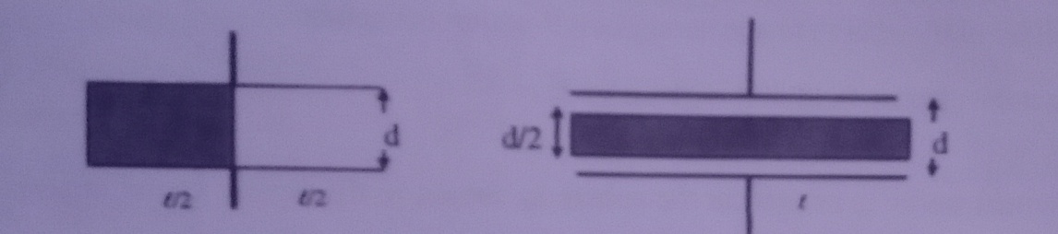

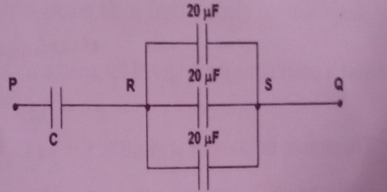
- - Calculate the capacitance of the capacitor see in figure the equivalent capacitance of the combination between P and Q is 30 micro Farad.

  - A 20 microfarad capacitor is charged by a 30 volt dc supply and then connected across an uncharged 50 microfarad capacitor calculate: i) the final potential difference across the combination. ii) initial and final energies . How will you account for the difference energies?

