PRAYAG PUBLIC SCHOOL AND COLLEGE
Holiday Home Assignment
Information Technology -402
Class-10
Note:--

- The whole holiday assignment has been divided into three categories SECTION-A,SECTION-B AND SECTION –C make the best use of your time in this lockdown period and complete all your assignment very honestly and sincerely as directed.
- All the assignment in SECTION-A have to be done in Computer Register copy.
- All the assignment in SECTION –B has to be done in your Holiday homework register (Combined register for all the subjects.)
- SECTION-C contaions some projects and activities, which have to be done either homework register or Project/Activity file.
- All the assignment will be throughly checked when school will be open and marks will be given for each assignment.

SECTION-C (Project and Activity) Date:-21/06/20 to 30/06/20

Make an Activity file on the given topics.Marks should be calculated in Half Yearly Examination.
Instructions:
- Front page displaying all your details along with subject code and teacher Incharge.
- Index and Page number and Teachers signature.
- Screenshots are required in 2,3,4,11,12.
- Software: MS-Word, MS-Excel, Ms –Powerpoint, MS-Access

Ms- Word
- Create a word Processor file that prints a bill of items as bought in a gift shop named “TOKEN _OF_LOVE”.
The Bill should have
  - Welcome image should be on the Top.
  - A watermark
  - Font should be decorative
  - Customer name
  - Mode of Payment
  - Date of Purchased
  - Items Purchased with Price and Discount

Name of Item | Price of Item | Discount | Final Price
Diamond Pendant | 27000 | 10 % | 26730
Gold Earrings | 18000 | 7% | 16740
Case | 500 | - | 500
Total |  |  | 43970

Sample :
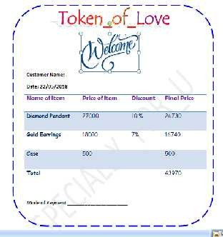

- Using the Smart Art of MS –word create a chart on the generations of Computer.
- You are Abhinav/Anu of class X. Using the Word Processing Software write an application to the school principal for three days leave.(Using paragraph spacing as 1.5 and all use all required alignment )
- Create a word document and enter some information related to your friends, separated the information with tabs. Now convert the text to the table format. Make the table look beautiful.
MS-Excel
- The Sales Report
Write the data given below using the Spreadsheet Software. Name the sheet1 tab as Data

- Title Column should be left align, year, Genre sales unit rental unit should be centre align.
- The row height should be 18.5
- Sort the whole data in the ascending order of unit sales.
- Create the bar chart for the following data.
- Using the conditional formatting colour as follows :
  - Red colour for those records that was launched before 2010.
  - Green colour for those records that was launched after 2010.
  - Yellow for 2010.

Title | Year | Genre | 2016 Unit Sales | 2016 Unit Rentals
The Artist | 2011 | Drama | 5 | 20
Argo | 2012 | Drama | 15 | 150
Mutiny on the Bounty | 1935 | Drama | 3 | 2
Oliver! | 1968 | Musical | 20 | 200
In the Heat of the Night | 1967 | Drama | 4 | 10
The Sting | 1973 | Comedy | 8 | 15
The Godfather | 1972 | Drama | 15 | 40

- Here is the data of a survey regarding favorite food conducted among 45 students of a class. Draw a pie chart for this data.
Food Item | Number of students
Pizza | 15
Dosa | 6
Noodles | 9
Burger | 10
Soup | 5
- The table given below shows the number of visitors to different stalls at a funfair event.
- Calculate the total number of visitors per day.
- Compute the total number of visitors and their avg across four days for each stalls.
- Draw a Bar graph for the data.

STALLS | DAY 1 | DAY 2 | DAY 3 | DAY 4
SHOOTING A BALLOON | 20 | 25 | 30 | 35
THROWING A RING | 30 | 40 | 50 | 45
MAGIC SHOW | 25 | 30 | 30 | 35
JUGGLING | 30 | 35 | 40 | 60
DOG SHOW | 10 | 15 | 20 | 25
FACE PAINITNG | 20 | 25 | 30 | 20
Tariq Fashions maintains their employee salary details in a spreadsheet as shown below. Fill the blanks using the Excel formulae.
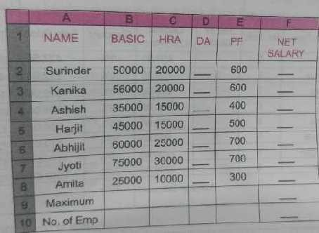
- To Calculate the DA as 25% of BASIC +HRA for each employee and display in column D.
- To calculate the NETSALARY as BASIC +HRA +DA –PF for each employee and display in column E.
- To find the Maximum Net Salary and Display in Cell F9.
- To count the number of employees and display in cell B10.
- The manager inserts a column for S.NO in the above spreadsheet. Which feature will help him to do the same?
- If the Basic Salary of an employee changes, will the manager have to redo all the Calculations for the particular employee? Explain.
- Given below a screenshot for Sri Lanka’s Cricket Player’s. You have to create the same spreadsheet and
calculate the total score and Strike rate for the all players.(Mention all the required formulae)
  - Formula for total score is by adding all score
  - For strike rate is total score/ balls faced *100
  - Using freeze pane option ,Freeze the first two crickets’ record.(row 4 and 5)
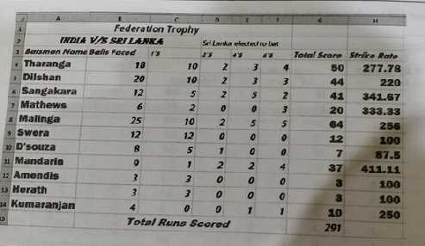

Powerpoint Presentation
- Create a Powerpoint Presentation on any one of the following topic :
- Cyber Security
- National Integration
- Introduce any new software
- My Inspiration
- Student may be asked to present it in the class. (prepare for it)
- Maintain the colour combination theme.
- Submit the softcopy to your subject teacher via email by mentioning Rollno and class in subject
o Pooja.khanna@bps.edu.in or sonali.gulati@bps.edu.in
- Use animation , images, hyperlink, notes view
- 1st slide your name and details last slide- Thankyou and ask the audience for doubts
- Include sources as well.

Ms –Access
- Create a table in a database to design and enter the details of employees of an organization. (any 10 employees)
- Name of the employee
- Employee_Id
- Date_of_joining
- Posting
- Department
- Basic_Salary
  - Sort the data based on basic salary in the ascending order.

Email Messaging
- Book a meeting and send the request to your 4 friend’s to be attendees. After sending and saving the meeting in the calendar, update the time of the meeting. Send the updated times to the 4 attendees. Use email client for the purpose.
(Hint use calendar view and right click on the date in calendar to choose New Meeting Request).

[WISH YOU BEST FOR THE SUMMER VACATION]

