कक्षा 10 हिंदी गृहकार्य
(21जून से 30जून )

कृतिका - पाठ 1 माता पिता का आंचल को ध्यानपूर्वक पढ़कर कठिन शब्दों के अर्थ लिखकर याद कीजिए। पाठ के प्रत्येक अनुच्छेद से पांच-पांच छोटे प्रश्नोत्तर बनाकर लिखिए। पाठ के अंत में दिए गए प्रश्न उत्तर कॉपी में कीजिए।
व्याकरण - वाक्य की परिभाषा लिखकर रचना की दृष्टि से उसके तीन भेदों को उदाहरण सहित लिखकर याद कीजिए। उनका परस्पर वाक्य रुपांतरण कीजिए।
वाच्य की परिभाषा लिखकर उसके तीन भेदों को उदाहरण सहित लिखिए। उनका परस्पर वाच्य परिवर्तन कीजिए।
पद परिचय के लिए विकारी और अविकारी की परिभाषा और उसके भेदों को उदाहरण सहित लिखिए।
(1 जुलाई से 10जुलाई)
निबंध लेखन - नैतिक पतन देश का पतन, मतदान केंद्र का आंखों देखा वर्णन, पुस्तक मेला की उपयोगिता, मेरे जीवन का लक्ष्य, मेरे सपनों का भारत विषयों पर 200-250 शब्दों के निबंध लिखिए।
लेखन - व्याकरण की पुस्तक से पांच औपचारिक और पांच अनौपचारिक पत्र लिखिए तथा
पांच विषयों पर विज्ञापन लेखन लिखिए।
व्याकरण की पुस्तक से 5 अपठित गद्यांश के प्रश्नोत्तर हल करके लिखिए।
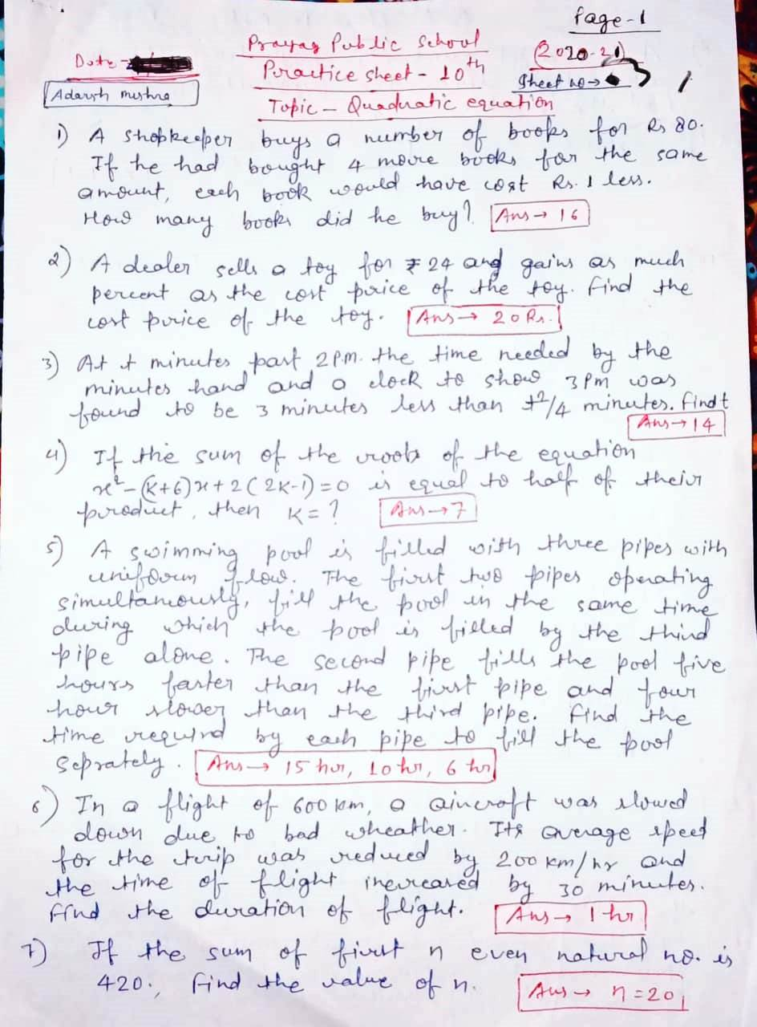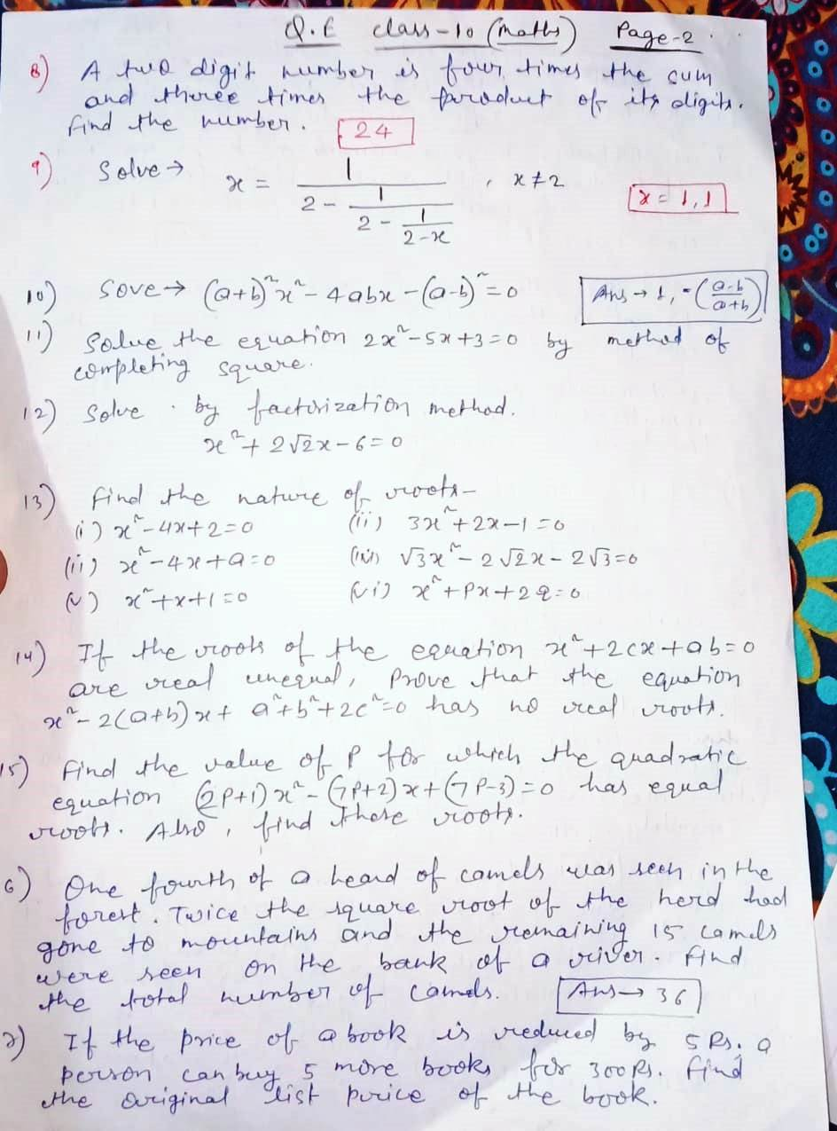
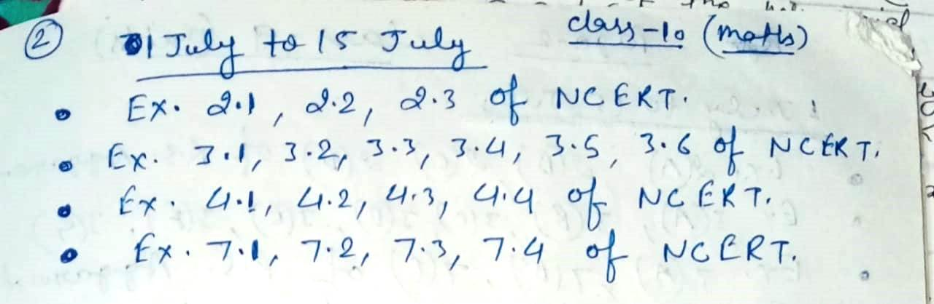

Holiday Homework
Class-X {sub: science}

NOTE : All the Q/A ,exercise , activity, project has been given from your text book. Please refer the book. All the assignment will be thoroughly checked whenever school respond and marks will be assigned according to your work.

Date : June 20 to July 10

Physics
Q1. Read chapter motion and make a proper note.
Q2. Do exercise given on page no 108 ,109 and 110 of your physics books.
Q3. Do NTSE-SAT (Target: scholastic aptitude test) given on page no 118 and 119 of your physics books. [note: make another copy for these competitive based question only]
Q4. Write 15 assertion-reason based question by yourself in your homework copy.
Q5. Make a chart paper on topic electric generator and electric motor.
Q6. State the law which gives the direction of magnetic field lines in determined.
Q7. What are similarities between current carrying solenoid and bar magnet.
Q8. Define : 1 tesla , 1 weber and 1 Newton .

Chemistry
1. Read the chapter acid, base and salt from your chemistry book and do the practice exercise 2A (page89 ) and 2B (page102) in your homework notebook.
2. Write the formula of following compound or salt.
- Copper sulphate
- Potassium carbonate
- Sodium hydrogen carbonate
- Sodium chloride
- Sodium acetate
- Aluminium chloride
3. Why is the Plaster of Paris written as CaSO4 ½ H2O how is it possible to have half a water molecule attached to Caso4.
4. How does baking soda help to make cake and bread soft and spongy .how does it help in extinguishing fire?
5. what is salt explain the various type of salt.
6. Write the importance of PH in everyday life.
7. Name three acid obtained from Natural sources.
8. A student dropped a few pieces of marble in dilute HCl contained in a test tube .the evolved gas is passed through lime water ,what change would be observed in lime water .write the balanced chemical equation for both changes observed
9. During summer season a milkman usually adds a very small amount of baking soda to fresh milk. give one reason.
10. Tap water can conduct electricity whereas distilled water does not, why.
11. What is arrhenius and Lewis concept of acid and base.

Biology
1. Read the chapter Reproduction from your Biology book and do the practice exercise 3A (page172) and 3B (page184) in your homework notebook.
2. what is variation write the importance of variation.
3. why degeneration is beneficial in simple multicellular organism but not in complex multicellular organisms?
4. how does an embryo get nourishment inside the Mother’s body.
5. what is the cause of variation or write the importance of reproduction.
6. why is DNA copying necessary during reproduction.
7. cell division is a type of reproduction in unicellular organism, justify it.
8. state the role of placenta in development of embryo what happens when the egg is not fertilized.
9. No two individual are absolutely alike in of population ,why.
10. Explain any four method of contraception used by human.
11. what is the effect of DNA copying, which is not perfectly accurate in the reproduction process ,how does amount of DNA remain constant through each new generation.
12. explain the role of following in human male reproductive system.. testes ,seminal vesicles, vas difference, ureter prostate gland.
13. what is pollination how does it occurs in plant.
14. explain the role of following in human female reproductive system.. ovary, oviduct ,uterus.
15. what is placenta describe its structure and role

Date: July 10 to July30

Physics
- An electron of charge -1.6× 10⁻¹⁹ C and mass 9×10⁻³¹ kg moving with a velocity of 10⁶ m/s. it enters in a magnetic field of 3.0 weber/m² at angle of 30⁰ . calculate the force acting on the electron and its acceleration.
- Describe with the figure Fleming’s left and right hand rule.
- Clarify the process of energy transformation in an electric motor.
- Find the unit of magnetic field intensity in term of force and current. What is the relation of gauss with other units?
- Draw the magnetic field lines due to a current carrying conductor. And also write the characteristics of magnetic field lines.
Biology
- Do all question of NCERT file from page 188 in your notebook fair.
- colonies of yeast fail to multiply in water but multiply in sugar solution, give reason.
- Why sexual reproduction is beneficial to survive in unfavourable condition.
- Do the chapter practice test from page 222 in your notebook fair.
5.Activity.( do in activity file)
- To show Rapid budding in yeast.
- To demonstrate the vegetative propagation by money plant.
- Project (Do in project file)
- draw the structure of male and female reproductive system and write short notes on them.
- Write short notes on type of reproduction.
Chemistry
- Do all question of NCERT file from page 105 in your notebook fair.
2.Write the preparation and use of NaCl and baking soda.
3. What is plaster of paris. explain the preparation of plaster of Paris.
4.Activity.
- To show that crystalline salt contain water of crystallization
- To show that dilution of an acid in water is an exothermic process.
5.project
- Write short notes on indicator and their types.
- Write short notes on chemical and physical property of acid and base.

