PRAYAG PUBLIC SCHOOL AND COLLEGE PRAYAGRAJ
CLASS 12 COMMERCE Holiday Home Work
ACCOUNTANCY
(Date 1 June -10 June )
1. Solve all the questions of Issue of Shares including forfeiture, Re-issue, amd pro-rata based .
2. Solve all the practical questions of Issue of Debentures chapter .
3. Write all question's answer in fair copy which was provided to all of you in the assignment sheet.
4. Solve practical question upto 1 to 50 questions from D K Goel chapter Accounting Ratio.

INDIAN ECONOMIC DEVELOPMENT
(Date 11 June - 20 June )
1. Write 20 questions and answers in their copy from Human capital formation in India.
2. Solve all the questions which was provided to you in the assignment sheet from chapter Poverty and five year plan in India .
3. Solve 25 questions from Features, problems and policies of Indian agriculture.
4. Read at least two new chapter and prepare notes with 25 questions.
MACRO ECONOMICS
( Date 21 June - 30 June )
1. Revise all chapter and make proper notes ( money, banking, aggregate demand and supply ) .
2. Write about the following topics- RBI, Commercial bank, Bank related rates, demonetization, Import Exports.
3. Present situation of our economy is too low give your ideas to balanced.
4. If you are finance minister take some proper action to improve the economy . write the proper notes.
5. Read National income with the help of YouTube or Google.
6. Solve all the questions from aggregate demand and it's components.
7. Write all the hots questions from above lesson in your assignment copy.
BUSINESS STUDIES
( Date 1 July - 10 July )
1. Revision of all chapter ( nature and significance of management, principle of management, planning,organising,).
2. Make proper assignment copy with all the questions.
3. Solve all the case study from your business book.
4. Find 200 MCQ from sample paper of last 10 years paper .
5. Complete Staffing, Directing, and Controlling chapter with the help of my videos.

Class:12 Prayag Public School Sub:Bio
Summer vacation work sheet
Worksheet:1 (June1 to june10)
1. Name the most invasive aquatic plant weed which is called as ‘Terror of Bengal’.
2. Offsprings produced by asexual reproduction are referred to as clones. Why?
3. Study the relationship between first two words and suggest a suitable word for fourth place.
(a) Chlamydomonas : Zoospores :: Penicilium : .............................
(b) Ginger : Rhizome :: Agave : .............................
4. Fill in the gaps.
The period from birth to the natural death of an organism represents its…………………
5. Asexual reproduction is seen in which of the following pair of organisms.
(a) Amoeba and Hydra
(b) Penicillium and Hibiscus
(c) Rose and Earthworm
(d) Leech and Cockroach
6. Fill in the blanks
The site of zygote formation is the ………………..present inside the ovule of a flowering plant.
6. Bryophytes and Pteridophytes produce a large number of male gametes but relatively very few
female gametes. Give one reason.
7. The male gametes of rice plant have 12 chromosomes in their nucleus. The chromosome number
in the female gamete, zygote and the cells of the seedling will be, respectively,
a. 12, 24, 12
b. 24, 12, 12
c. 12, 24, 24
d. 24, 12, 24.

Worksheet:2 (June11 to June20)
1. What is thalamus?
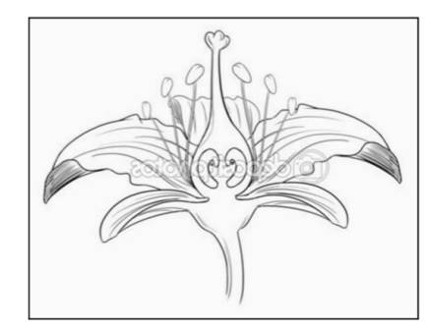
2. Label any four parts of the given flower

4. What is the function of androecium ?
5. What is the function of gynoecium ?
6. Write the name of four wall of microsporangium?
7. Define microsporogenesis?
8. What is microspore tetrad?
9. What is sporopollenin?
10. Write the name of four wall of microsporangium?
11. Define microsporogenesis?
12. What is microspore tetrad?
13. What is sporopollenin?
14. Draw the diagram of maize seed and label any four parts.
15. Write the example of two albuminous and non albuminous seed.
16. Write one difference between true and false fruit.
17. Give any two examples of fleshy and dry fruits.
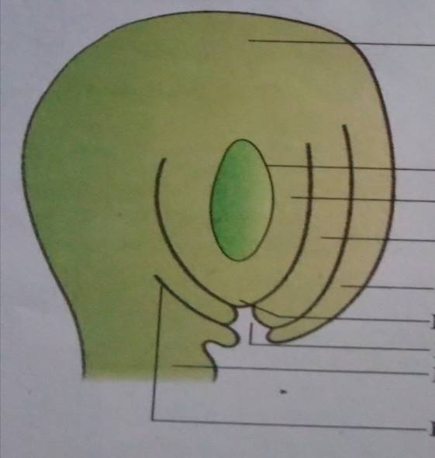
18. Write short note on parthenocarpic fruits. Give an example.
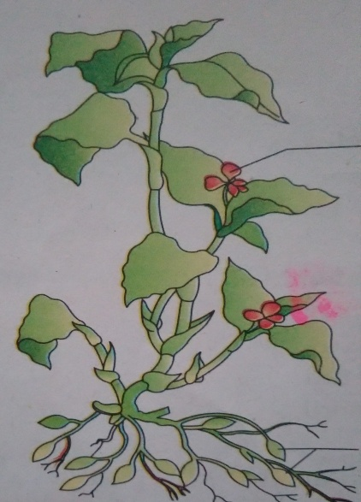
19: identify and label the following diagrams. Which type of pollination occurs in in diagram b.

- B
1. Choose the correct option
Thee process of gametogenesis starts at
a) The time of birth
b) Puberty
c) During embryogenesis
d) The childhood
16 primary spermatocytes undergoes the first meiotic division to form________ haploid
secondary spermatocytes.
a) 16
b) 32
c) 64
d) 08
Sertoli cells provide __________ to the growing sperms.
a) Nourishment
b) Mobility
c) Energy
d) Lubrication
2 Match the following column A and B:-
COLUMN A COLUMN B
I. Spermatogenesis a) anterior portion of sperm
II. Follicle stimulating hormone (FSH) b) formation of a mature female gamete
III. ovulation. c) transformation of spermatids to sperm
IV. acrosome. d) acts on the Sertoli cells V. oogenesis
e) release of ovum
VI. spermiogenesis. f) formation of a mature male gamete
3 Fill in the following blanks:-
1. The release of sperm from seminiferous tubules is known as_______________.
2. Sperm is composed of ahead, __________ and a middle piece.
3. Gametogenesis is the process of formation of ___________ in gonads.
4. Tail in sperm helps in __________.
5. luteinising hormone (LH) acts at the Leydig cells and stimulates synthesis and secretion
of___________.
4 State whether true or false.
1. The sperm head contains an elongated haploid nucleus.
2. The seminal plasma along with the sperms constitute the semen.
3. Oogonia are keep on forming though out the life in the ovary.
4. Antrum is the fluid filled cavity of tertiary follicle.
5. Middle piece of sperm have numerous plastids.

5. Identify and label the following diagram.
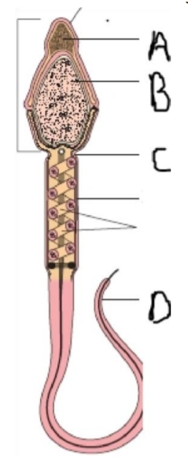
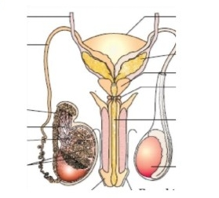
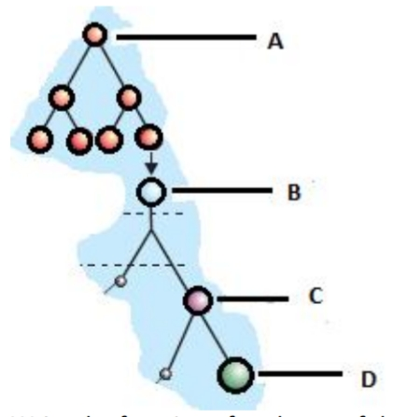
6. Label A,B, C and D in the following schematic representation of oogenesis.

Worksheet:3 (June21 to June30)
1. Identify the stage b, c, d, e and f of embryonic development by looking at the diagrams
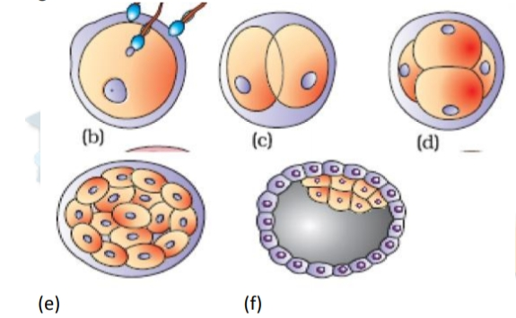
given below:
What is the name of a cell in stage b and c
2. Name the cell organelles present in the neck of a human sperm.
3. Which sugar is present in seminal plasma?
4. What is the function of the cells of alveoli in respect to mammary gland?
5. Which structure in an ovary is characterised by a fluid filled cavity called antrum?
6. What is the ploidy of the first and second polar body respectively?
7. Name the tissue which secrete estrogens and progestogens for the maintenance of
Pregnancy
8. Mention two functions of FSH during the follicular phase of mensrual cycle. 2
9. Mention the accessory glands of male reproductive system. Give a term to the
secretions of these glands collectively.
10. How does the enzymes of the acrosome help in fertilisation?
11. Draw a neat and a labelled diagram of a blastocyst. Where are stem cell found in the blastocyst?

12. What are the hormones which are released only during pregnancy? Mention one
function of each
13. Study the diagram and answer the following question:
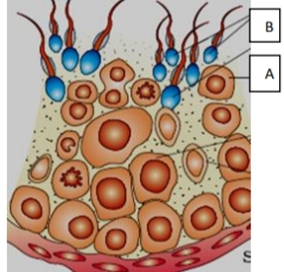

a) Identify ‘A’ and ‘B’.
b) Which cell division takes place to form a primary spermatocyte from spermatogonia?
c) State the function of interstitial cells

Activity (July 01 to July 10 )
1.Observe the various kinds of flowering plants to your surroundings and collect their flower, and examine the number of anther and stigma.
2. Trying to find out which animals visit them and whether they could be pollinators of these flowering plants.
3. Trying to make a list of farming seeds and vegetable in your field and also mention the how these are reproduce
4. Make a menstrual hygiene poster for aware the people of your area. How you can break the Taboo about the menstruation.

