CLASS 8TH
HOLIDAY H.W
General Instruction:- it is compulsory for everyone to read the chapter thoroughly and complete the given assignment on given dates
Lesson- 1 Computer Network
JUNE 1-10
- Write about the classification of computer and its characteristic and drawbacks.
- Briefly write about various Generation of computer.
- Write a note on 7th generation.
- Give the detail of 4th gen of computer and 5th gen of computer.
- Define the following terms
- Android b. Graphics c. SIM d. Vol Lte in mobile network. e USB d Microprocessor
June 11- 20
- Describe cyber threats and prevention.
- Write about computer network and its function.
- Explain the characteristic of computer network.
- Write down the various types of networks used in computer architecture.
- Define the following terms:-
- Network interface card(NIC)
- Communication Media and its types
- HUB/Switch
- Peer to Peer Network.

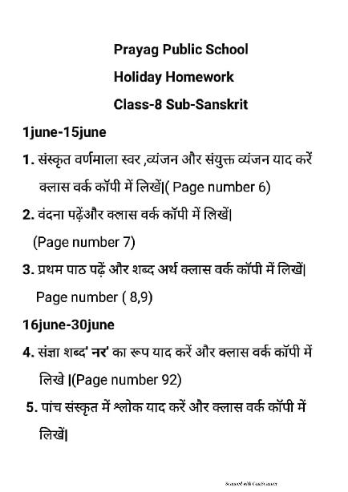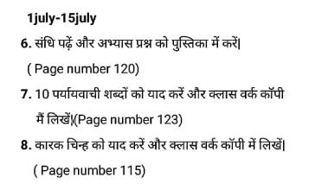
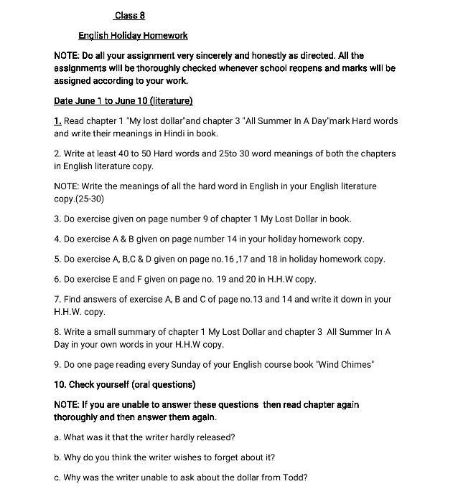

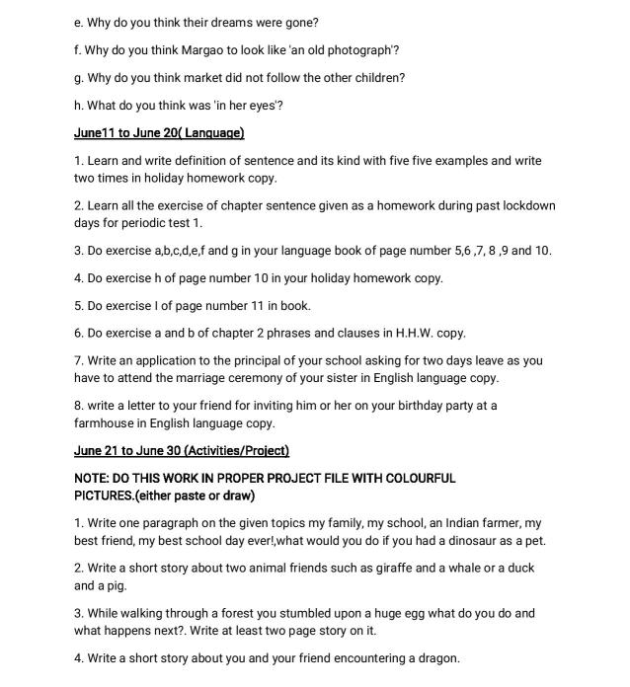
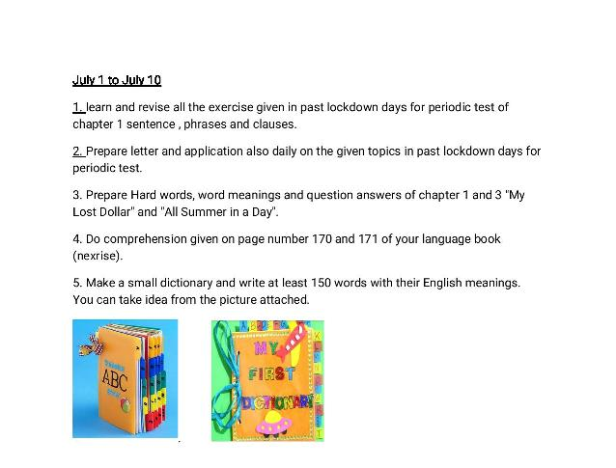

Holiday Homework. June 1 to June 10
Class 8. Subject. History
Note: All the Q /A, Activity, Exercise, Project has been given from your school Text book.
Please refer Chapter 1 and 2 of History.
Q.1 Write and learn All the following key terms.
Colonisation, Renaissance, Revolution, Industrial Revolution, Imperialism, Colonialism, Nationalism, Inscriptions, Merchantilism, Annexation, Alliance, Subsidiary Alliance.
Q.2 Write all the MCQ , Match the following and 'Very Short Answers' in your Copy.
Q.3 List the factors responsible for Colonialism and Imperialism.

History June 11 to June 20
Map Work :
Q.4 On the Map of India Show 'Expansion of British India 1857’ [ Page no.17]
Case study
Q.5 Read the Case study 'ANGLO – FRENCH RIVALRY IN INDIA' [Page no.12]
Q.6 Write a Short Note on following topics [5 to 6 lines]
(a) Battle of Plassey
(b) Battle of Buxar
(C) Third Anglo – Mysore War
(d) The Second Anglo – Maratha War
Q.7 Learn and Write the Merits and Demerits of Subsidiary Alliance. [Page no. 16]
Diary Making :
Q.8 Collect pictures of some important personalities whose names have been mentioned in connection with the struggle/conquest of Bengal. also write two sentences on each.
HOLIDAY ASSIGNMENT
CLASS 8TH ---SCIENCE

NOTE-
1-The whole holiday assignment has been divided into three categories SECTION A , SECTION B AND SECTION C.make the best use of your time in this lockdown period and complete all your assignment very honestly and sincerely as directed.
2-All the assignments in SECTION A have to be done in scinece interleaf copy( CW COPY) in a very neat and clean handwriting.
3-All the assignments in SECTION B have to be done in your holiday homework register(combined register for all the subjects).
3-SECTION C contains some projects and activities which have to be done either in holiday homework register or project/activity file.
4-All the assignment will be thoroughly checked when school will be open and marks will be given for each assignment.

SECTION--A
DATE--01/06/20 TO 10/06/20
1--- Note down and learn the following topics in your science cw copy.
LESSON-1-CROP PRODUCTION AND MANAGEMENT.
Agriculture: The applied branch of biology which deals with cultivation of plants and rearing of animals is called agriculture. Generally, the art or practice of cultivating land is referred as agriculture. The branch of agriculture which deals with food, health and management of animals is known as animal husbandry.
• Crop: When plants of the same kind are grown and cultivated at one place on a large scale is called as a crop.
• Crops are also classified on the basis of the seasons as given below:
▸ Kharif Crops: The crops which are grown during the monsoon (rainy) season (June-September) are called kharif crops. For example, maize, millet (bajra) and cotton crops. Seeds of these crops are sown in the beginning of the monsoon season. After maturation, these crops are harvested at the end of the monsoon season (Oct.-Nov.).
▸ Rabi Crops: Crops which are grown during the winter season (October-March) are called rabi crops. For example, wheat, gram and mustard. Seeds of these crops are sown in the beginning of the winter season. After maturation of crops, they are harvested at the end of the winter season (April-May).

• Agricultural Practices: All activities which farmers do for the cultivation of plants are called agricultural practices.
For doing various activities, a farmer needs different types of tools. These tools which are involved in cultivation of plants are called agricultural implements. Farmers perform agricultural practices in a sequence.
• Various Agricultural Practices:
(i) Preparation of soil
(ii) Sowing
(iii) Adding manure and fertilizers
(iv) Irrigation
(v) Protection from weeds
(vi) Harvesting
(vii) Storage.
• Agricultural Implements:
▸ Plough
▸ Hoe
▸ Cultivator
▸ Seed drill
• Implements used for traditional ways of Irrigation:
▸(a) Moat
(b) Dhekli
(c) Rahat
(d) Chain pump and
(e) Motor pumps

• Basic Practices of Crop Production
▸ Preparation of Soil: Before sowing the crop seeds, the soil of fields is loosened and overturned.
This process is called ploughing or tilling. Ploughing causes ventilation of soil and makes it suitable for the growth of small organisms living in it.
▸ Sowing of Seeds: For sowing, farmers obtain certified seeds from State Agriculture Department and Seed Corporation. Sometimes, farmers also select seeds from their own crop. For selection of seeds of most of the crops, seeds are put into a bucket of water. The seeds which float on water are rejected. These seeds are defective. The seeds which remain submerged in water are selected for sowing. The selected seeds are treated with chemicals such as agrosan or ceresan. This chemical treatment protects seedling from seed-borne diseases. Seeds are sown either by hand-broadcasting (spreading) or by seed drills . A type of seed drill, commonly used, is a long iron pipe having a funnel at the top. It is tied at the back of the plough .
A farmer does ploughing and simultaneously releases seeds from the funnel. Seeds thus released pass through iron pipe to the soil furrows which are formed by the plough.
▸ Adding Manure and Fertilisers: Like other plants, crop plants also obtain their mineral nutrients from the soil. Continuous growing of crop in the field causes deficiency of mineral nutrients in the soil. So, the manure is added to the soil to make up the deficiency of mineral nutrients. This process is called manuring. Manure is prepared from cow dung, urine and other wastes.
Sometimes, soil becomes deficient in a particular mineral nutrients. This happens when same crop is grown in the same field year after year. For example, a particular crop takes more phosphate. If this crop is grown in a field every year, the soil will become deficient in phosphorus nutrient. This type of deficiency of a particular nutrient is made up by adding chemical substances called fertilisers. For example: urea, super phosphate and NPK (Nitrogen, Phosphorus, Potassium).
▸ Irrigation: The supply of water to crops at different intervals is called irrigation. The time and frequency of irrigation varies from crop to crop, soil to soil and season to season.

• Protection from Weed
The unwanted plants in the fields are called weeds. Seeds of these weeds spread through the agencies like air, water, birds and other animals. Weeds share water, sunlight, space, nutrients with the crop plants. Thus they compete with the crop plants. Therefore, their removal is necessary. Otherwise, crop plants do not get sufficient space, water, sunlight and nutrient to grow healthier. Weeds are weeded out either by hand or with the help of an implement called harrow. Nowadays, for checking the growth of weeds, certain chemicals are used. These chemicals are called weedicides, such as 2, 4-D.

• Harvesting and Threshing: When crops pet matured, they usually turn yellow or golden or brown. This is the time when crops should be cut. Cutting of crops is known as harvesting. Harvesting is either done manually by a sickle or by a machine called harvester. Harvested crop is further dried and then animals such as bullocks, buffaloes, camels are made to walk over it. The grains are separated from chaff with the help of wind (winnowing) . The whole process of separation of the grains from the harvested crop is known as threshing.
Big farmers use huge machines known as combines which do both harvesting and threshing.

▸ Storage: Grains obtained by threshing are dried in the open. The dried grains are stored in gunny bags, and placed in properly ventilated cemented halls, known as godowns. Farmers keep dried grains in jute bags or metallic bins or mud bins. Large scale storage of grains is done in silos and granaries . For storing large quantities of grains in big godowns, specific chemical treatments are used to protect them from pests and microorganisms.

• Animal Husbandary: Food is also obtained from animals for which animals are reared and provided with proper food, shelter and care. When done on a large scale, it is called animal husbandry.

2---Read and understand lesson "1--crop production and management " and find/write answers of all the questions asked in the exercises of your text book.(pg. No. 27.. Short and long questions both: write answers in your cw copy)

3--Complete/learn all the exercises given on pg. No. 26 in your textbook.

CLASS 8TH--SCIENCE HHW

DATE--10/06/20 to 20/06/20

SECTION--B

1-- Find answers of the following q/a and write answers in your holiday home work copy.

Lesson 4--materials..metals and non metals

1. Explain displacement reaction with the help of an activity.

2. Explain the reaction of non-metals with oxygen with the help of an acitivity.

3. Write the uses of metals and non-metals.

4. Write the difference between metals and non-metals on the basis of their physical properties.

5. Name two most ductile metals.

6. Sodium is stored in kerosene. Why?

7. What are oxides? Write the nature of metallic and non-metallic oxides.

8. Explain displacement reaction with the help of an example.

9. Explain the reactions of metals and non-metals with (i) Acids (ii) Air (iii) Water.

10. Write the uses of metals and non-metals in our daily life.

11. What do you mean by displacement reaction?

12. Give one example of displacement reaction.

13. Have you ever seen a blacksmith beating an iron piece? Do you find a change in the shape of these pieces on beating? Would you expect a similar change in wood log on beating?

14. What is malleability? Name two most malleable metals.

15. Explain that metals are good conductors of electricity with the help of an activity.

16. List some physical properties of the metals.

17. Write some physical properties of non-metals.

18. What happens when a magnesium ribbon is heated in presence of air?

19. What happens when a copper vessel is exposed in moist air?

*Learn and write following q/a in your HHW COPY

Q. Give reasons for the following.

(a) Aluminium foils are used to wrap food items.

(b) Immersion rods for heating liquids are made up of metallic substances.

(c) Copper cannot displace zinc from its salt solution.

(d) Sodium and potassium are stored in kerosene.

Ans. (a) Aluminium is malleable, soft and does not react with food items, so it is used to wrap food items.

(b) Metals are good conductor of heat and electricity, so immersion rods are made up of metallic substances.

(c) Copper is less reactive than zinc, so it can not displace zinc from its salt solution.

(d) Sodium and Potassium are very reactive; they react with air and water, so they are stored in kerosene.

Q. Can you store lemon pickle in an aluminium utensil? Explain.

Ans. No, we cannot store the lemon pickle in aluminium utensil because aluminium is a metal and lemon is acidic. The acids react with metals to give hydrogen which would spoil the food and makes it unfit to use.

Q. What happens when

(a) Dilute sulphuric acid is poured on a copper plate?

(b) Iron nails are placed in a copper sulphate solution?

Write word equations of the reaction involved.

Ans. (a) When dilute sulphuric acid is poured on a copper plate, copper reacts with acid to give copper sulphate and hydrogen.

Sulphuric acid + Copper → Copper sulphate + Hydrogen

(b) When iron nails are placed in copper sulphate solution, displacement reaction takes place in which iron displaces copper.

Copper sulphate + Iron → Iron sulphate + Copper

The blue colour turns into green.

Q. Saloni took a piece of burning charcoal and collected the gas evolved in test tube.

(a) How will she find the nature of the gas?

(b) Write down word equations of all the reactions taking place in this process.

Ans. (a) When charcoal burnt then carbon dioxide gas is formed. This gas turns lime water into milky substance. It can also be tested by red and blue litmus. The solution of gas turns blue litmus into red so it is acidic.

(b) Carbon + Oxygen → Carbon dioxide

Carbon dioxide + Lime water → Milky

Q. One day Reeta went to a jewellers shop with her mother. Her mother gave an old gold jewellery to the goldsmith to polish. Next day when they brought the jewellery back, they found that there was a slight loss in its weight. Can you suggest a reason for the loss in weight?

Ans. Gold is a metal which is washed in acidic solution. Some gold dissolves in acid to form oxide. This causes the loss of gold in the form of gold oxide. In this process certain amount of gold is lost to the acidic solution.

2-- Find answers and write in your HHW copy.

Lesson 2..microorganism:friend and foe

1. What are microorganisms or microbes?
2. Give two examples of microorganisms.
3. Name two multicellular Microorganisms.
4. What are the two types of Microorganisms on the basis of their functions?
5. Who discovered the antibiotics?
6. What is vaccine?
7. What do you mean by vaccination?
8. Name the pathogen of anthrax.
9. Where do Rhizobium bacteria commonly live?
10. Edward Jenner in 1798.
11. Which is the carrier of dengue virus?
12. What do you mean by food preservation?
13. Who discovered the antibiotics?
14. Name a popular vaccination programme.
15. Where do Rhizobium bacteria commonly live?
*हिंदी गृह कार्य
कक्षा 8

(हिंदी व्याकरण)

(1June to 10June)
१.व्याकरण की पुस्तक के सभी पाठों के नाम अपनी व्याकरण की कक्ष कार्य पुस्तिका में सुसज्जित रूप में क्रमानुसार लिखिए।
२. व्याकरण की पुस्तक में दिए गए समस्त पाठों की प्रमुख परिभाषाएं सुसज्जित रूप में क्रमानुसार व्याकरण की कक्ष कार्य पुस्तिका में लिखिए।(पृष्ठ संख्या-247-248)

(11June to 20June)
३. निबंध लेखन-(1)आतंकवाद और विश्व शांति(2)भारत की शान डॉ अमर्त्य सेन (3)विज्ञान और जीवन(4)राष्ट्रमंडल खेल (5)जीवन में खेलकूद का महत्व।(पृष्ठ संख्या-231-233)

४- पत्रलेखन-
(अनौपचारिक पत्र)
(1)मामा के विवाह पर मित्र को निमंत्रण पत्र, (2)छात्रावास से माता पिता को पत्र, (3)मित्र की मां के आकस्मिक निधन पर पत्र। (पृष्ठ संख्या-216-217)

५-पत्र लेखन- (औपचारिक पत्र) (1)प्रधानाचार्य को अवकाश हेतु प्रार्थना पत्र (2)प्रधानाचार्य को हिंदी दिवस पर कवि सम्मेलन आयोजित करने हेतु पत्र। (3)डाकिए की शिकायत करते हुए डाकपाल को पत्र।(पृष्ठ संख्या- 217 -218)

