PRAYAG PUBLIC SCHOOL & COLLEGE LALGOPALGANJ PRAYAGRAJ
HOLIDAY HOMEWORK
CLASS – IX (2020-2021)
SUBJECT- SCIENCE
NOTE : All the Q/A ,exercise , activity, project has been given from your text book. Please refer the book. All the assignment will be thoroughly checked whenever school respond and marks will be assigned according to your work.
DATE JUNE 1 TO JUNE 10

Physics
- Read chapter motion and make a proper note.
- Do exercise given on page no 54 and 55 of your physics book.
- Do NTSE-SAT (Target: scholastic aptitude test) given on page no 65,66,6768&69 of your physics book [note: make another copy for these competitive based question only]
- Write 15 assertion-reason based question by your self in your homework copy.
- Make chart paper on use of study of motion in physical world.
- On a 120 km road, a car travels the first 30 km at a uniform speed of 30km/hr. How fast must the car travel for the rest of track so as to have an average speed of km/hr for the entire journey?
- Can a body have acceleration in one direction velocity in another direction?
Chemistry
- Read the chapter matter in our surrounding from your chemistry book and do practice exercise 1A (page 15) in your homework notebook.
- Read the chapter matter in our surrounding and do practice exercise1B (page 25) in your homework notebook.
- Why should we wear cotton clothes in summer?
- Why do we see water droplets on the outer surface of a glass containing Ice cold water?
- Why does camphor change direct from solid to gas on heating.
- Why can we get the smell of perfume sitting several metres away.
- Define the following term:
Evaporation, factor affecting evaporation, latent heat of fusion, latent heat of vaporization, sublimation, liquefaction, gas pressure, diffusion.
Biology
- Read the chapter the fundamental unit of life from your Biology book and do practice exercise 1A (page 15) in your homework notebook.
- Read the chapter fundamental unit of life and do practice exercise1B (page 25) in your homework notebook.
- What is “omnis cellula e cellula “who is stated it.
- What is membrane biogenesis how does plasma membrane formed during membrane biogenesis.
- Do all question of NCERT file from page 30 in your notebook fair.
- Differentiate between Plant cell and Animal cell.
- Atom all question of chapter practice test from page 15 in your notebook fair.

DATE: JUNE 11 TO JUNE 20
Physics

1. Define acceleration and state its SI unit. For motion along a straight line, when do we consider the acceleration to be (i) positive (ii) negative? Give an example of a body in uniform acceleration.
2. Find the total displacement of the body from the following graph:
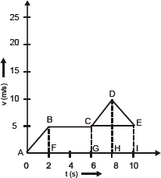
3. A car travels at 54 km/h for first 20 s, 36 km/h for next 30 s and finally 18 km/h for next 10 s. Find its average speed.
4. Define acceleration and give its SI unit. When is acceleration of a body negative? Give two examples of situations in which acceleration of the body is negative.
5. Distinguish between uniform motion and non, uniform motion. Is uniformly accelerated motion uniform motion? Give one example each of uniform and non-uniform motion.
6. The speedometer readings of a car are shown below. Find the acceleration of the car and its displacement.
Time | Speedometer
9:25 am  9:45 am | 36 km/h  72 km/h
- Define uniform circular motion and give example of it. Why is it called accelerated motion?

BIOLOGY
- Read the chapter tissue from your biology book and do practice exercise 2A( from page 60 )and 2B( from page 74 )in your notebook fair. Do all question of NCERT file from page 77 in your notebook fair.
- Do the activity in activity file.
Activity -1 To Show the occurrence of osmosis through cell membrane.
Activity -2 To show the phenomenon of plasmolysis.
- Do the following project in project file.
project -1 Draw the well labelled diagram of plant cell.
project-2 Write short notes on animal tissue.
CHEMISTRY
- Do all question of NCERT file from page 29 to 31 in your notebook fair.
- Convert the following temperature to Celsius scale.
- 300k , 573k, 200k, 1k, 2k,
3. What is the physical state of water at 25,0, and 100 degree Celsius.
4. Why is ice at 273 Kelvin more effective in cooling than water at same temperature.
- Do the activity in activity file.
Activity -l To Show the compressibility of solid liquid and gas.
Activity-ll To demonstrate that diffusion of different substance is different.
Activity-lll To demonstrate that particles of matter are very small.
4.Do the following project in project file.
project-l Show the interconversion of three state of matter.
project-ll Write short notes on state of matter write the general characteristic of each state of
matter.
Class IX Computer
Lesson -1
June -1-10
Read the chapter thoroughly and complete the Assignment.
- Write the definite of communication cycle.
- Explain about communication process eg . a two way process.
- Write down the effective feature of communication which help in better communication.
- Write in short on the following communication
- Message b. Sender c. Encoding d. receiver e. communication Channel. F. Decoding.
- Define the following terms
- Environmental barrier
- Situational barrier
- Linguistic ability

June 11-20
- Write down some important point on following IT personalities
Billgates 2. Mark zukerberg 3. Sundar pichai 4. Tim berner lee 5.. Satya narayana Nadella
- Draw a diagram of communication cycle in book and explain in note book
कक्षा 9 हिंदी गृहकार्य
(1जून से 10जून)
क्षितिज (गद्यखंड) -
पाठ-1 दो बैलों की कथा को ध्यानपूर्वक पढ़कर कठिन शब्दों के अर्थ लिखकर याद कीजिए। पाठ के प्रत्येक अनुच्छेद से पांच-पांच छोटे प्रश्नोत्तर बनाकर लिखिए। पाठ के अंत में दिए गए प्रश्नोत्तर कॉपी में कीजिए। पाठ के लेखक प्रेमचंद के जीवन परिचय, रचनाएं और साहित्यिक परिचय पर एक परियोजना तैयार कीजिए।
पाठ 2 ल्हासा की ओर को पढ़कर उसके शब्दार्थ याद कीजिए। 20 अतिरिक्त प्रश्नोत्तर लिखिए। पाठ के अंत में दिए प्रश्नोत्तर कीजिए।
(11जून से 20जून)
क्षितिज (काव्य खंड) - पाठ 15 मेघ आए कविता को ध्यानपूर्वक पढ़कर शब्दार्थ और व्याख्या लिखकर याद कीजिए। कविता के प्रत्येक काव्यांश से पांच-पांच छोटे प्रश्नोत्तर बनाकर लिखिए। पाठ के अंत में दिए गए प्रश्न उत्तर कॉपी में कीजिए।
कवि सर्वेश्वर दयाल सक्सेना की काव्य शैली पर अपने विचार व्यक्त कीजिए।
पाठ 9 कबीरदास की साखियाँ और सबद के शब्दार्थ और प्रश्नोत्तर याद कीजिए।
दोहे और साखी कण्ठस्थ कीजिए।
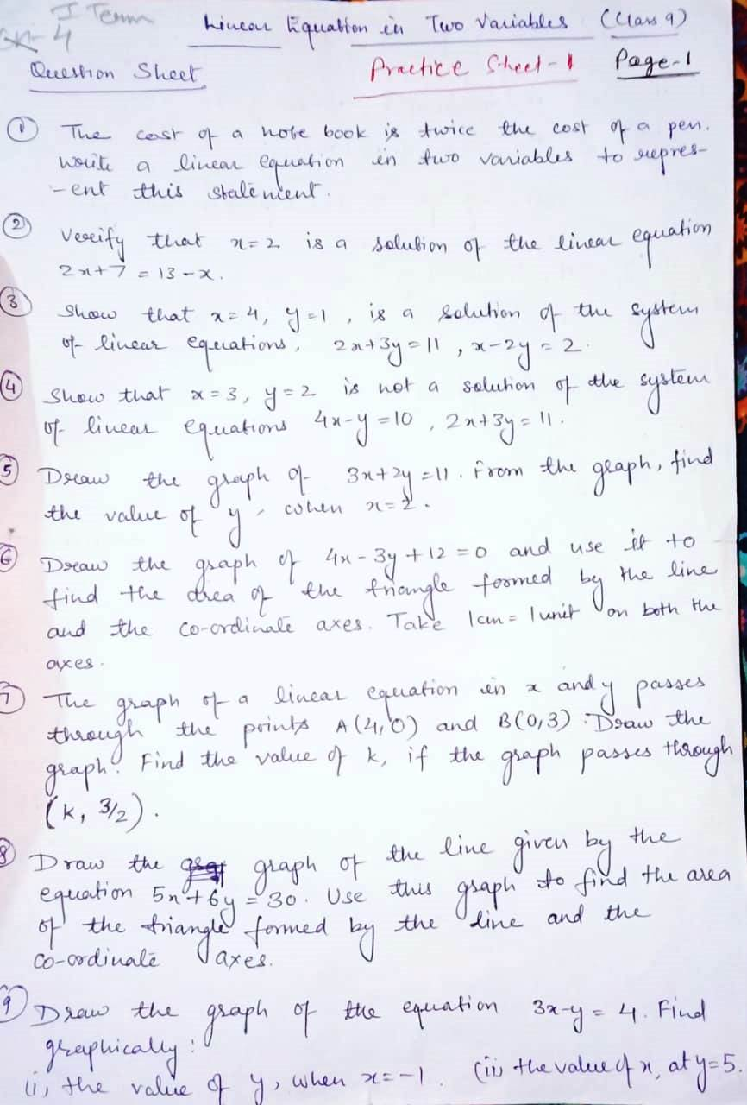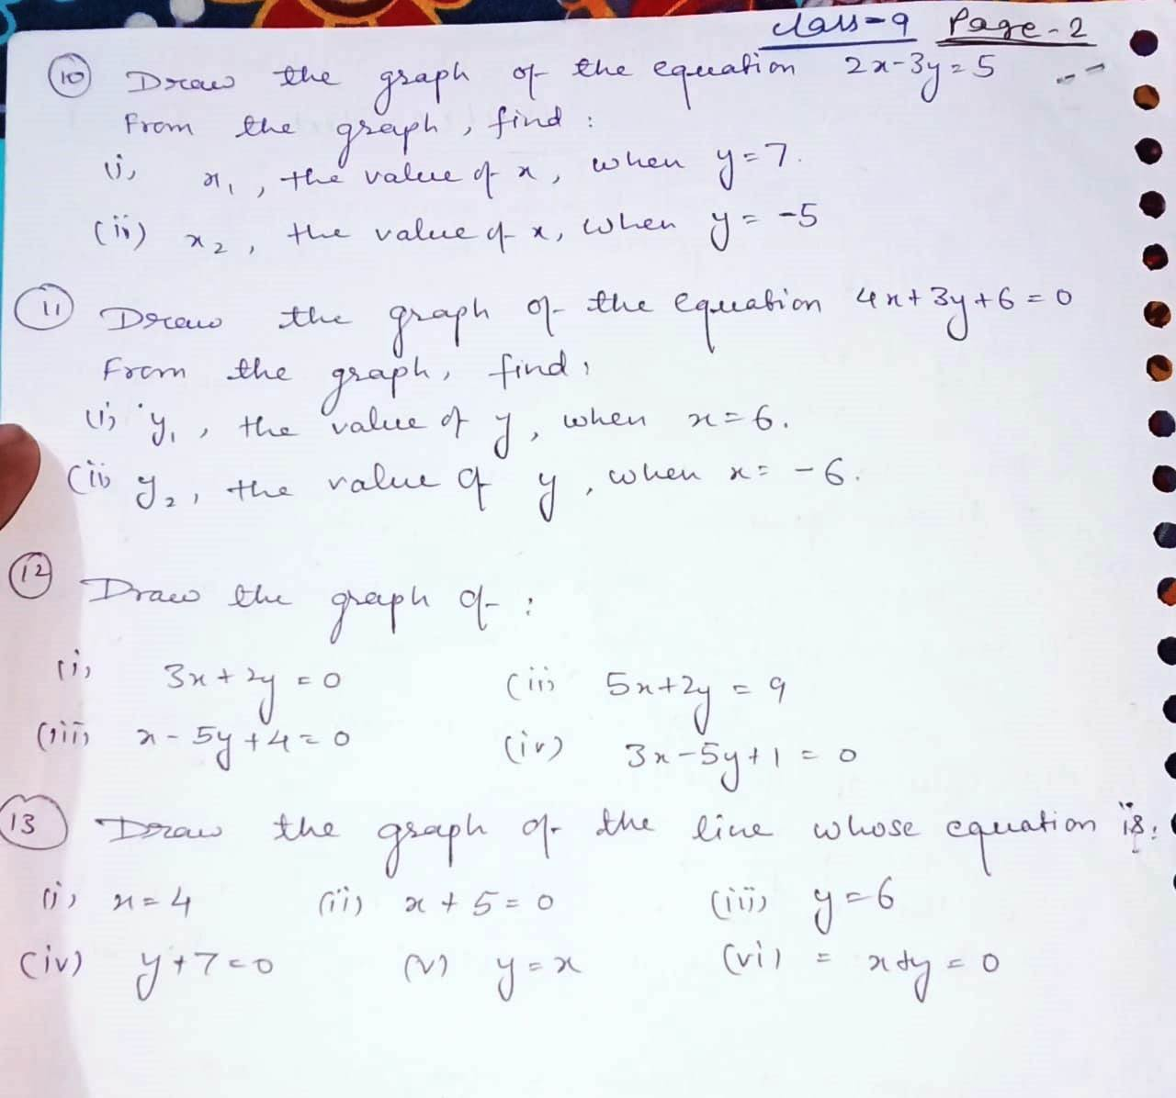
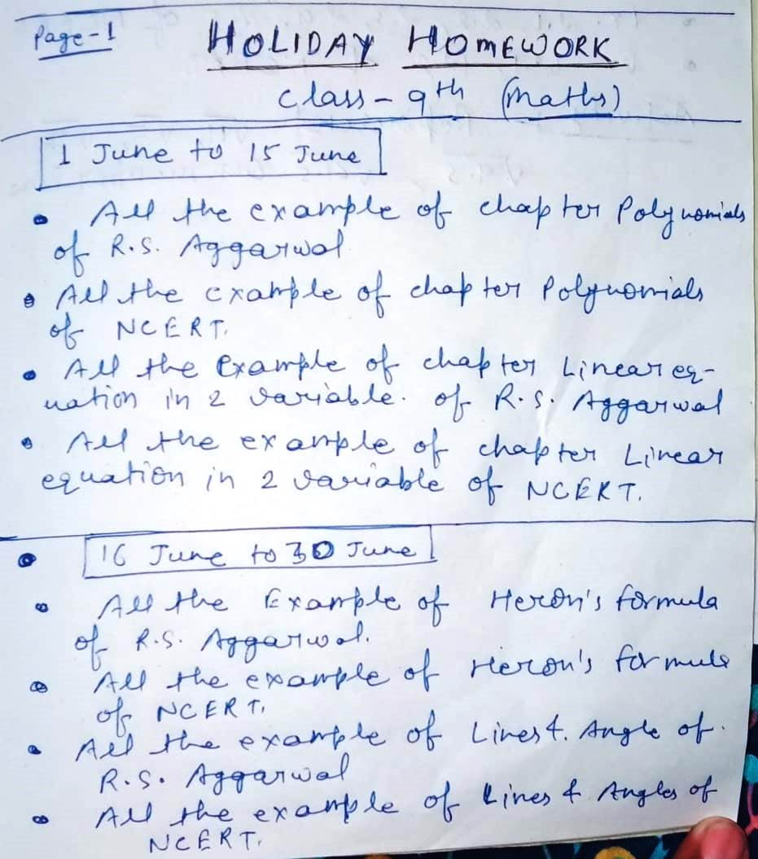

WORKSHEET CLASS 9 S.St (1 to 10 june) [Download by given link]
https://drive.google.com/file/d/1cLDKQrFQDz2BMyNNcfrzZsGT9ErDVFxe/view?usp=sharing

